GOVERNMENT DEGREE COLLEGE :: RAMACHANDRAPRAM

DEPARTMENT OF HINDI

Dr. N. V. RAMANA, M.A., P.G.D.F.H.T., S.H.P.T., Ph.D., HOD of Hindi Dept.

STUDENT HIGHER PROGRESSION

Two Students are Qualified to do PG Hindi course in Department of Hindi, Andhra University, Visakhapatnam. They Joined in 2023-24 Academic Year. Recently they were completed their PG Course successfully with higher grades in M. A Hindi.

1.P.PRIYANKA 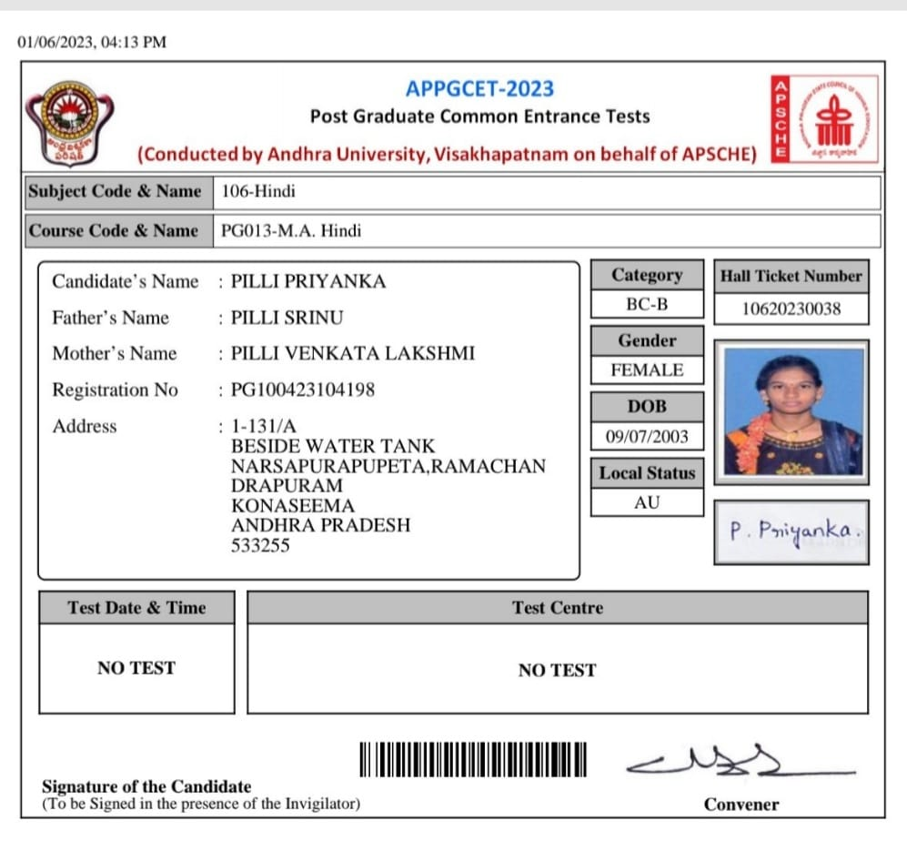

2.Ch.VIDHATRI 